COME JOIN US

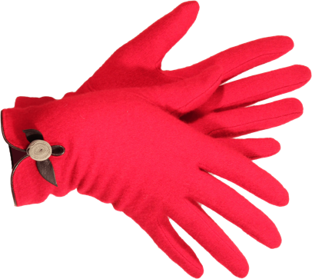
Canton Garden Center Presents:
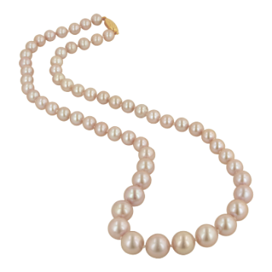
Fall Fundraiser
“GARDEN GLOVES AND PEARLS”

Saturday, October 22, 2022
La Pizzaria, Crystal Room
Doors open at 11 am Lunch at Noon
$30.00
Delicious Family-Style Lunch Gift Basket Raffle and More

Sisterhood of the Traveling Plants Program by Celine Hallier

