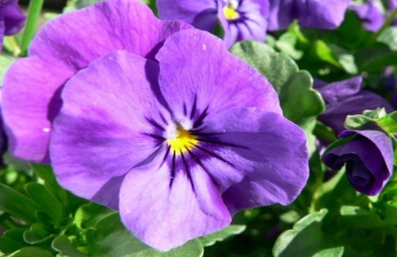
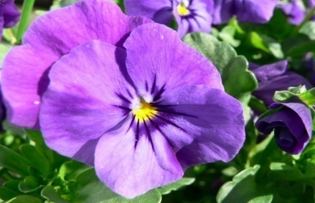

CANTON GARDEN CENTER
ICE PANSY SALE
Imagine your planters filled with beautiful color in APRIL!

Get a jump start on the growing season and order Cool Wave pansies that are a hardier variety of pansy which will bloom longer and stronger in your garden or your container! Each 4 1/2" pot contains one large plant and sells for $5. Orders are filled on a first ordered, first filled basis. Pansies will be available for pickup at the Canton Garden Center April 14 meeting.

Name of Garden Club:____________________________________
Your Name:_________________________ Phone:______________
# of Pots:_____________ x $5 each = $___________________

Payment must be included with order

Make checks payable to Canton Garden Center

Send payment to Celine Hallier
2696 Carlton St., NW
North Canton, OH 44720-5092

Questions? Call: Celine Hallier at 330-685-4274

