Canton Garden Center presents a “Make-It & Take-It” Workshop:
How to Grow Microgreens
Friday, August 18, 2017
10:00 a.m.
Location: Canton Garden Center  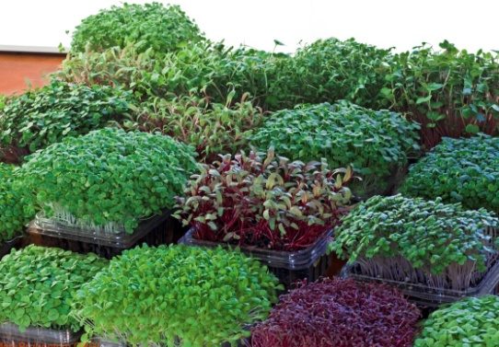 | We will:  - Learn why microgreens are so nutritious.  - Learn how to plant and harvest microgreens.  - Taste a variety of microgreens.  - Get recipe ideas.  - Learn various sources for ordering microgreen seeds.  - Plant some microgreens to take home.  Guests are welcome. Bring your friends.
Microgreens are the most nutritious vegetables on earth. You can easily and quickly grow them in controlled indoor places all year round. No matter the size of your apartment or house, you can be a farmer all year round! Learn how to effectively grow microgreens from planting to harvest. Potting soil, containers and seeds will be provided.
Cost: $15
Pre-paid reservations are due by August 9.
Cost: $15 Mail to: Charlotte Vazzano
(Make checks payable to Canton Garden Center) 6469 Harness Circle NE
For information, call 330-497-8633 North Canton, OH 44721-2491
Name: |  |  |  |  | Phone:
Email:
Garden Club:
Total Amount Enclosed:

Additional names can be listed on the back.

