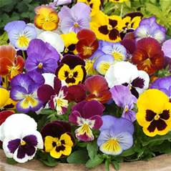
CANTON GARDEN CENTER
ICE PANSY SALE
Imagine your planters filled with beautiful color in April.
Pansies available at the April 11 meeting. Three mixed color pansies in a 5-inch pot for $5.00. Ready to plant. Orders filled on a first ordered first filled basis. Must be prepaid.
Name Phone # # of pots
____________ _____________ ______________
____________ _____________ ______________
____________ _____________ ______________
____________ _____________ ______________
____________ _____________ ______________
____________ _____________ ______________
____________ _____________ ______________
____________ _____________ ______________
Return this form with your check payable to Canton Garden Center and mail to: Pat Smith, 822 Sand Lot Circle, Louisville, Oh 44641
For more information call Pat at 330-875-9317.

